CSS

Styling purpose (you can say painting décor cosmetics etc

UI user interface what user is seeing on screen of website

Another thing for styling is using Css framework one well known of them known as “tailwind css” for example nextjs is framework of react js

Importance of tailwind can be verify by seeing question of tailwind css in installation of next js most fast programming language

*TAILWIND CSS*

Give you predefined classes (already written classes) of css & it is already installed while installing nextjs

In html if I have to give class to website so I just put h1 code

I will write class and attribute and name in opening tag of h1

Html & css || next js & tailwind

<h1class = “heading”> Aliza asad </h1>|| <h1className = “heading”> Aliza asad </h1>

classes are pre-generated available on tailwind on google

.Background color

.bold or thin

Application will be on page.tsx

When we use tailwind so tailwind overwrite all html styling for example as tailwind cancel html styling of h1 as bold and large in size tailwind overrides the default html styling

* Flex Box

When you make a website you first ensure that it should run across all devices with all stylings and features that thing known as “Mobile responsive”.

There are two things grid and flex box

On webpage you have 12 columns usage depend on you like either 12 x 1 or 6 x 2 or 4 x 3 and many more it is not necessary that all columns have same width first rule is to decide how many parts are you going to break the space ?

Remember

Bases components utilities 3 important things never delete this

How to start flex box

Navbar

3 columns logo

1

1

1 column

Tailwind css intellisense extension install

Make navbar by nav class name code must give height h and width w to navbar opening tag class name so it will show your required navbar than for start column or distribution of navbar we make div code like this <div className="bg-purple-700 h-10 w-96"></div> --🡪 for logo in navbar

But for second part or column when we mark code below this again by div so it is showing below the logo tag like this

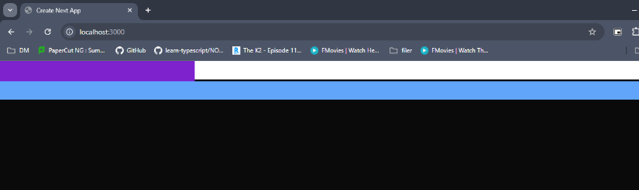

Parent tag of all coming ones is nav and div all under nav tag called child tags for example ul tag is parent tag of li tag as li is rendering under ul tag now always remember that flexbox styling always apply on parent element only By default div behavior is appearing line wise top to bottom not left to right so when we apply flex in class name of nav parent tag so it apply on navbar left to right like this

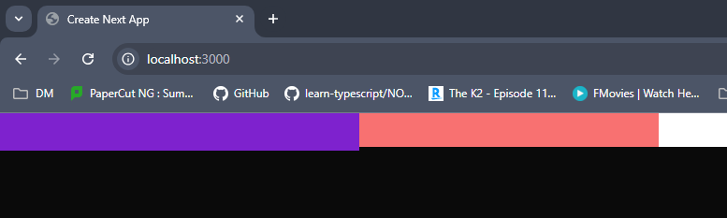

Width should be a number divisible by 10

To increase width of each part so change its parent tag div and apply flex and width in that parent tag so next coming all parts will carry that width but make sure parent tag of all div parent tags should be nav

Justify content: flex-start